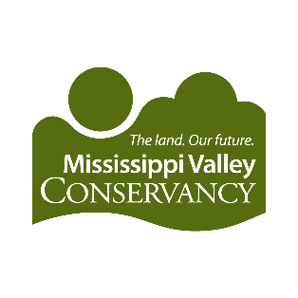
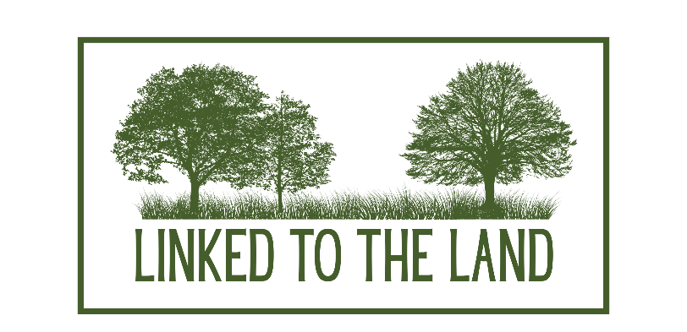
2026

DATE | ACTIVITY | LOCATION
January 9, 6-7 pm | The Science of Fire: How Controlled Burns Restore Native Prairies and Woodlands | Java Vino, La Crosse County
February 21, 10am - noon | Winter Birds of the Coulee Region | Viroqua Public Library, Vernon County
April 26, 11am - noon | Earth Fair Marsh Hike with Chuck Lee | Myrick Park/The Nature Place, La Crosse County
May 9, 7am- 9am | Migratory Birding Hike | Sugar Creek Bluff State Natural Area, Crawford County
June 11, 5-7pm (THURSDAY) | Habitat Typing & Forest Health with optional work party from 1-5pm | Wandering Rock State Natural Area, Buffalo County
June 27, 9-11am | Grazing for Birds | Plum Creek Conservation Area, Crawford County
July 11  (Times to be determined) | Bat Ecology Cave Tours – very limited spots available | Kickapoo Caverns, Crawford County
August 1, 9am – 11am | Bumblebee ID and Conservation | Private Landowner, Grant County
Date to be determined | How to grow and manage a prairie, Tom Lukens | Private Landowner, Vernon County
September 12, 10-noon | Science in the Stream: A Mussel Survey | Private Landowner, Jackson County
September 12, 5:30 – 9 pm | Gardens & Gazing | FSPA, La Crosse County
Oct 10, 8-10am | Fungi in the Forest | Kaplan Tract, La Crosse County
October 10, 7-9pm | Prairie Stargazing Hike | Tunnelville Cliffs, Vernon County

OTHER PARTNER OUTREACH DATES:
DATE | ACTIVITY | LOCATION
March | 2025 Leopold Weekend event | The Nature Place
End of August | Viterbo Back to School Bash | Viterbo, La Crosse County
First week of September | UWL Sample the City | UW-La Crosse, La Crosse County
Early October | La Crosse Adventure Festival – work party in collaboration with other local conservation groups | La Crosse Area
Assorted Volunteer For the Wild events throughout the year (view schedule online) | See EVENTS page on our website and sign up online

