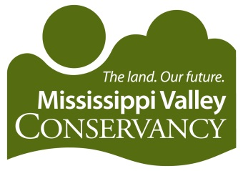

Conservation Internship

Mississippi Valley Conservancy (the Conservancy) is a regional, non-profit land trust based in La Crosse, WI that has permanently conserved over 26,000 acres of blufflands, prairies, wetlands, and streams in southwestern Wisconsin. The Conservancy owns and manages 27 nature preserves totaling more than 5,500 acres and also works with private landowners and local communities on voluntary conservation projects and environmental education in nine counties along or near the Mississippi River.

Summary of Position:
We are accepting applications for the position of Conservation Intern who will assist with land protection, land management, and mapping projects that support the conservation of southwest Wisconsin’s diverse landscapes. This valuable internship will provide extensive exposure and hands-on experience working with a land trust on various conservation projects, including conservation easement mapping and data gathering, database input, map-making for outreach materials, land management activities, and assisting with the annual monitoring of conservation easements.

Duties include assisting with land protection and land management projects; utilizing ArcGIS Pro and/or ArcMap to create property maps for private and public projects; loading and organizing maps and other data into the LANDSCAPE land conservation software; assisting in developing, implementing, and evaluating mapping capabilities for the organization; and assisting with field visits and annual monitoring visits as needed, which may include data collection/documentation and biotic inventories. Natural resources or GIS course work, other related coursework, and/or previous experience is required.

Knowledge, Skills, and Abilities:
- Enthusiasm for map-making and GIS
- Proficiency using ArcGIS Pro, Adobe, Microsoft Word, Excel
- Experience with online mapping programs
- Excellent writing, organizational and record-keeping skills
- Ability to work in an office setting for extended periods
- Ability to communicate effectively
- Ability to arrive on time, follow directions, and meet deadlines
- Ability to work independently and as part of a team

Details:

The Conservation Intern will work under the direction of the Conservancy’s Conservation Specialist and other Conservancy staff. The internship is part-time, unpaid (potential for college credit through your University), flexible timeframe (up to 5 – 10 hrs/week) and in-person, located at the Conservancy office in La Crosse, WI. The position may start as early as December 2025 and end May 2026.

How to Apply:
Please submit a resume, a brief (one page) cover letter including where/how you first found out about this position, and a list of 3 references in one PDF attachment to Conservation Specialist, Mitchel Block at mitchel@mississippivalleyconservancy.org. For more information, email or call Mitchel at 608-784-3606 ex.7.

